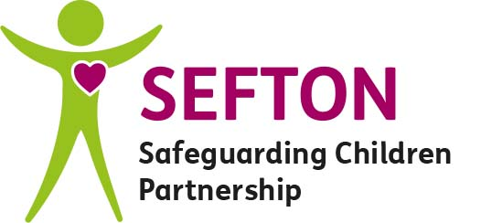

Sefton Safeguarding Children Partnership (SSCP) Professional Escalation Flowchart

Escalating Concerns: Step by Step – The Process
Escalation can be via telephone, face-to-face or internet meeting. All escalations should be recorded to ensure that the procedure is effective, transparent and for SSCP auditing purposes. Escalation via e-mail is not recommended as effective multi-agency working requires professional challenge in a suitable format and escalation is to resolve conflict and areas of concern relating to children and their families, a priority need. Any escalation should follow the steps below within the timescales stated.
Step 1
Direct Professional to Professional Discussion
Differences of opinion or judgment should be discussed amongst frontline professionals to attempt to achieve a shared understanding and agree a local resolution, in line with the plan, or to ensure a plan is developed if needed. This must occur immediately with an acknowledgement and mutually agreed plan of action, including timescales within 2 working days
Step 2
Direct Manager to Manager Discussion
If Step 1 does not resolve the issue then each professional should discuss the issue with their line manager or safeguarding supervisor. The line manager should review the concerns and ensure that they are justified and meet the purpose of this protocol. The line manager should then liaise with the other professional’s line manager in an attempt to reach a resolution. Consultation with senior managers within each organisation can be used if this would be felt to assist resolution. The discussion between managers must occur within a further 2 working days of step 1 (4 days total), with a mutually agreed plan of action including timescales. Respective Managers should record cases escalated using the Agency Escalation Summary Log (Appendix 1)
Step 3
Direct Head of Service to Head of Service Discussion
If Step 1 and 2 do not reach a mutually agreeable resolution, then the agencies’ Head of Service should be contacted immediately to liaise with the other agency’s Head of Service or assist as appropriate to resolve the conflict. A mutually agreeable plan of action including timescales should be in place within a further 2 working days (6 days total).
This may involve a resolution meeting to ensure the learning points are recorded and brought forward.
Respective Heads of Service should report to SSCP using the Report to SSCP (Appendix 2)
Step 4
Urgent resolution required - SSCP Independently Chaired Meeting
If the Senior Managers cannot resolve the issue that is causing conflict between professionals and agencies, then a meeting should be convened with an independent chair selected from the SSCP Senior Leadership Team.

SSCP Chaired Meeting will make final and binding decision for resolutions and communicate this to all WITHIN A FURTHER 5 WORKING DAYS (11 days total)
Outcome of the meeting should be reported to the SSCP using the Report to SSCP (Appendix 2)

At every step discussions and actions should take place within stated timescales and be followed up in writing, between the agencies, and recorded in single agency records.

“…practitioners’ responsibilities do not end at the point of referral to Children’s Social Care, but ends at the point where their professional concern is resolved….” Lord Laming – Chairman of Victoria Climbie Inquiry (2003)

Full escalation procedure available on www.seftonscp.org.uk (multi-agency procedures)

